Module 7: Lab Activity – Creating and Using Python Functions

Deliverables:
Python programs for the following problems. Use the names listed below:
- Problem1AreaOfCircle.py
- Problem2CheckRange.py
- Problem3MulitplyList.py
- Problem4Unique.py
- Problem5Squares.py
- Problem6ClassCar.py

All submitted code must include comments:

# Your Name
# The Date

# The Problem Number and Description

# Any other information throughout your code that is helpful

Python functions are a named sequence of statements that belong together.

All defined functions use the same setup. They consist of compound statements that include a header line and a body as shown below.
def functionName(parameter1, parameter2, etc)
# All statements that are part of this function are
# included here with indention
print(parameter1 + parameter2) # Sample statement

All defined functions must first be defined. To use them, they must be called, passing any needed parameters.

functionName(10, 20) # Sample function call using above example

Problem 1: Write a function areaOfCircle(r) which returns the area of a circle of radius r. Make sure you use the math module in your solution.

Problem 2: Write a Python function to check whether a number is in a given range. Use range(1,10). Print whether the number is in or not in the range.

Problem 3: Write a Python function to multiply all the numbers in a list. Use list [5, 2, 7, -1].

Problem 4: Write a Python function that takes a list of numbers and returns a new list with unique elements of the first list. Use list [1, 3, 3, 3, 6, 2, 3, 5]. Use the append function.

Problem 5: Use the following chunk of code as a base to produce the image shown below.

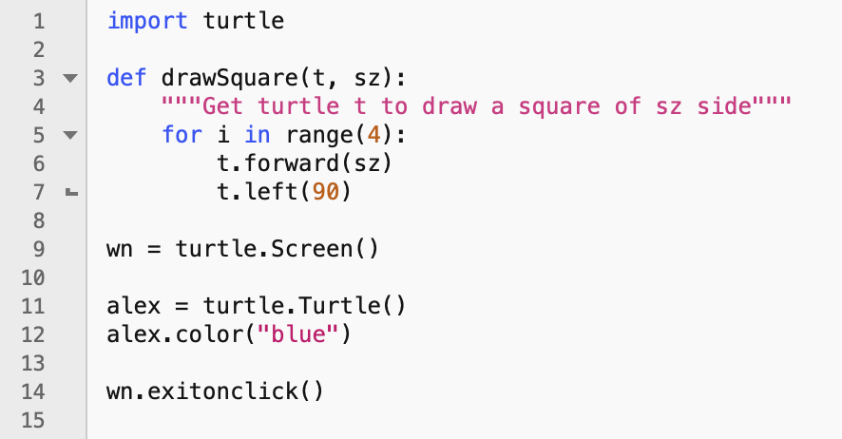

Problem 6: Given the following code with the Python Class ‘car’:

class car:
def __init__(self, model, year, color):
self.model = model
self.year = year
self.color = color
def get_model(self):
return self.model
def get_year(self):
return self.year
def get_color(self):
return self.color
def fullspecs(self):
return self.model + ' ' + str(self.year) + ' ' + self.color
car1 = car("Sports", 2012, "Blue")
car2 = car("Sedan", 2020, "Black")
print(car1.get_color())
print(car1.get_model())
print(car2.get_color())
print(car1.fullspecs())
print(car2.fullspecs())

Differentiate between an attribute and a method in a Python class definition.

Modify the code to add two additional attributes of ‘type’ and ‘manufacturer’. Then add their corresponding methods to print those attributes, don’t forget to also modify the method fullspecs() to return the additional attributes ‘type’ and ‘manufacturer’. Hint, read Chapter 17 of the course online textbook and watch the video Python OOP Tutorial 1: Classes and Instances - https://www.youtube.com/watch?v=ZDa-Z5JzLYM.

